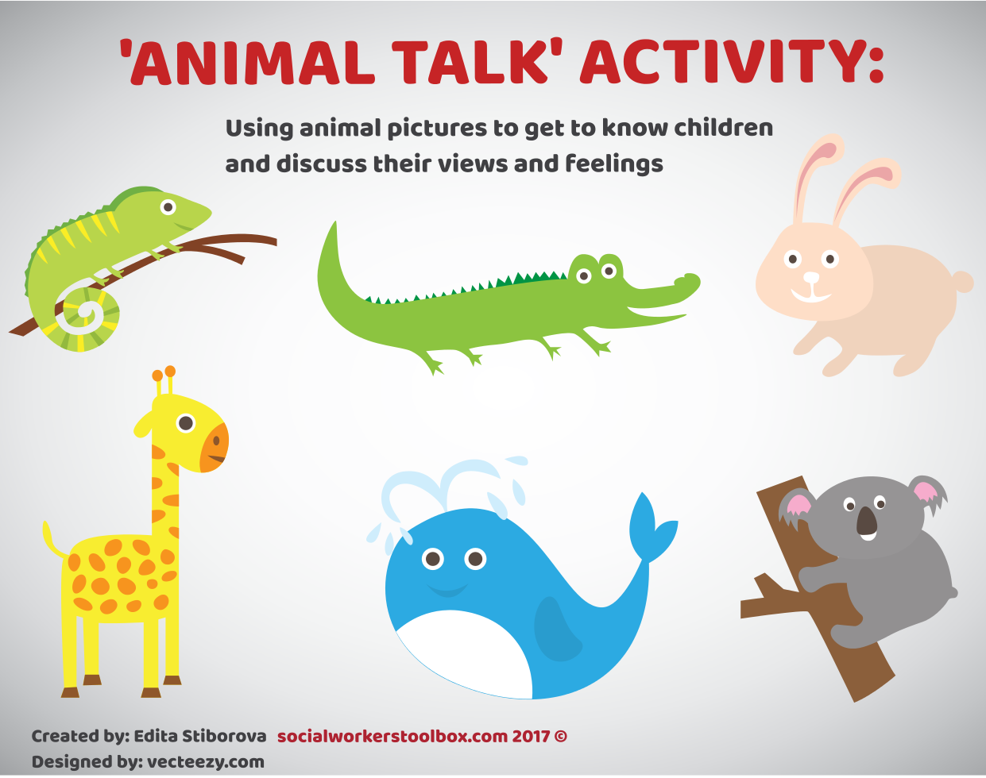

Preparation:
Print out the four sheets on the following pages and cut out each picture so that you end up with 24 individual pictures.

How to use the pictures:
Choose the activity which is most suitable for the child you work with -

1) Icebreaker; getting to know the child
Look through the pictures with the child and discuss their favourite animals with them. Ask various questions such as why they chose this particular animal, what do they know about the animal, whether they have seen it in a Zoo/on TV etc.
2) Establishing the child's feelings
Ask the child what feelings they think each animal/animals they picked has and why they think they feel that way. Explore what makes the child feel the same way or when was the last time they felt that particular way.
Example of conversation: "Yes, the dog looks very angry. What do you think makes him angry?... Yes, he may feel angry because somebody wants to attack him. What about you, what makes you angry?...or... Have you ever seen anybody being attacked by a dog or a person?"
You can also use the pictures to discuss a topic of your choice - for example, if working with a family where neglect is a feature, you can ask "What do you think the little birds in the picture need?" and then discuss the child's needs.
3) Establishing what the child thinks of themselves and the people around them
Talk about various qualities the animals in the pictures have (eg. dolphins are good swimmers; bears are strong and can be scary, bunnies are cute, cats like to be around people, mice can get to small spaces).
Ask the child to choose what animals they would like to be and why. Try not to limit them to just one animal as they may like some qualities of multiple animals.
Discuss if they have some of the same qualities as some of the animals.
Do the same for various family members or key people the child knows by asking them if they have some of the same qualities as some of the animals.
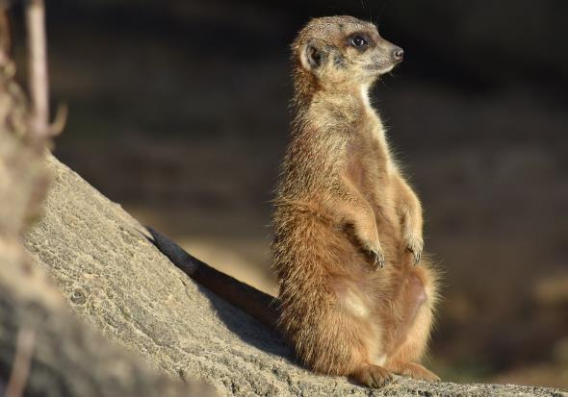 | 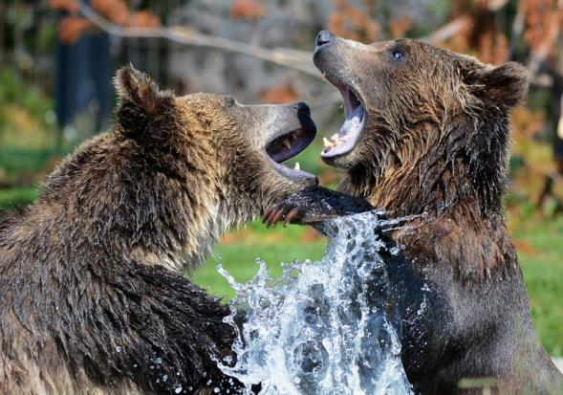
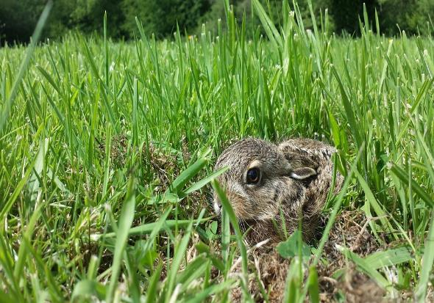 | 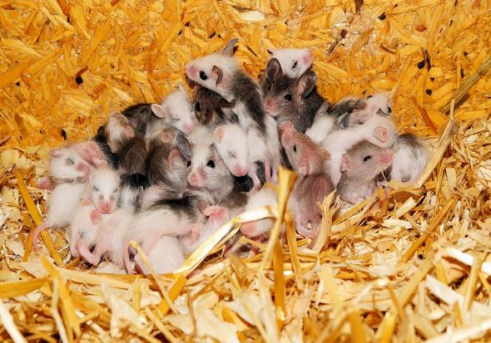
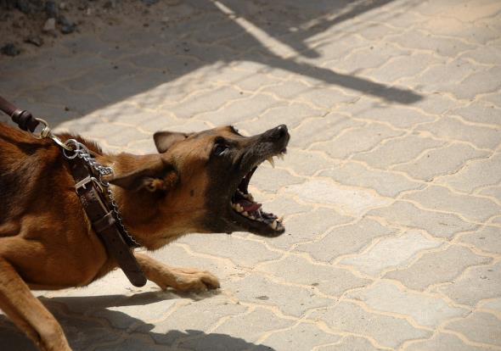
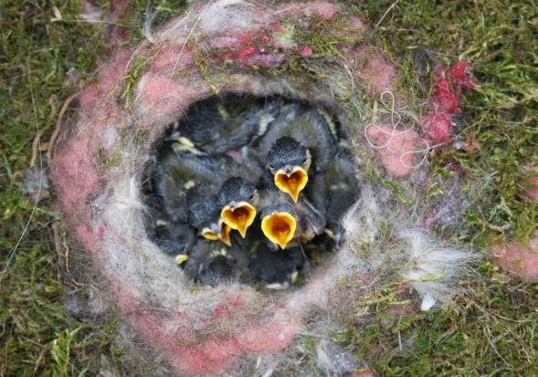 | 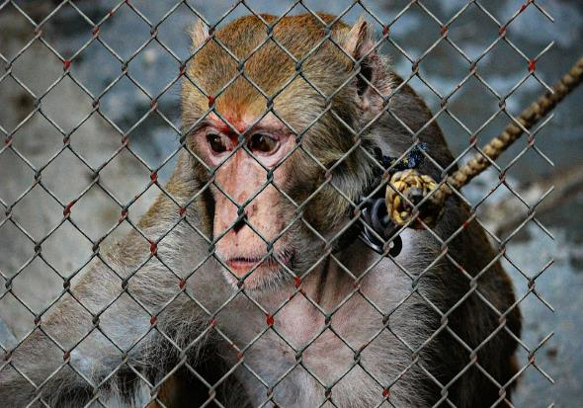
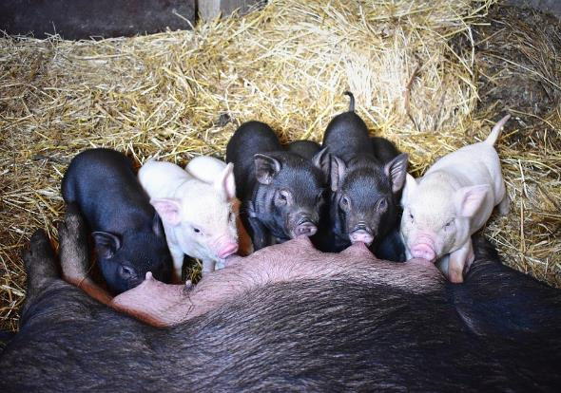 | 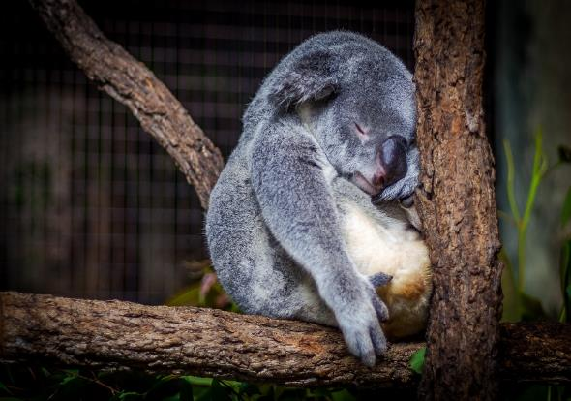
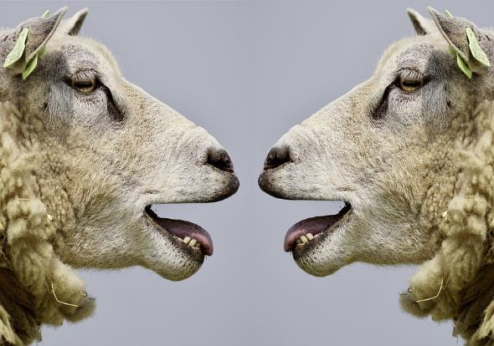 | 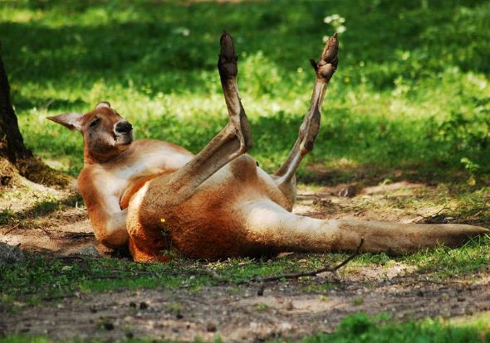
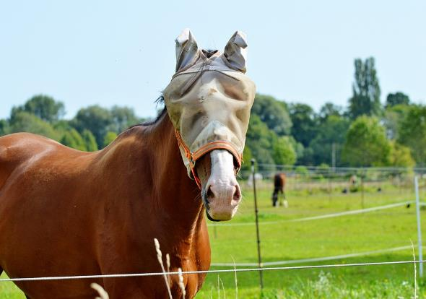 | 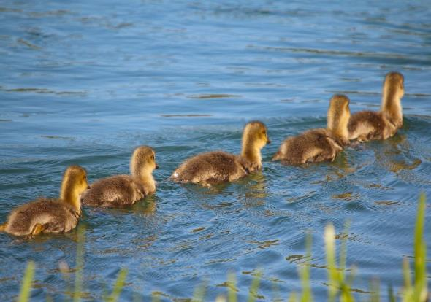
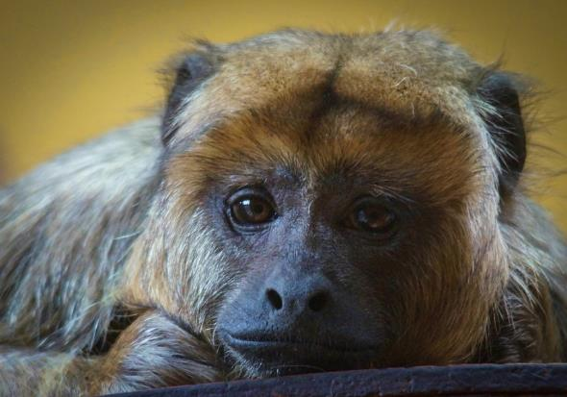 | 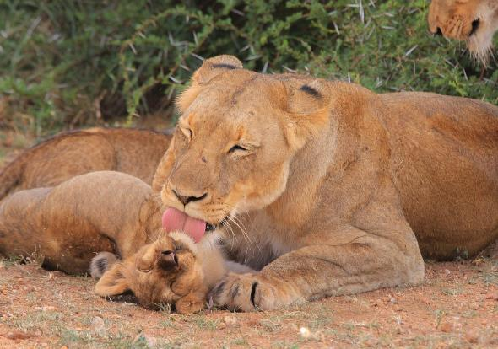
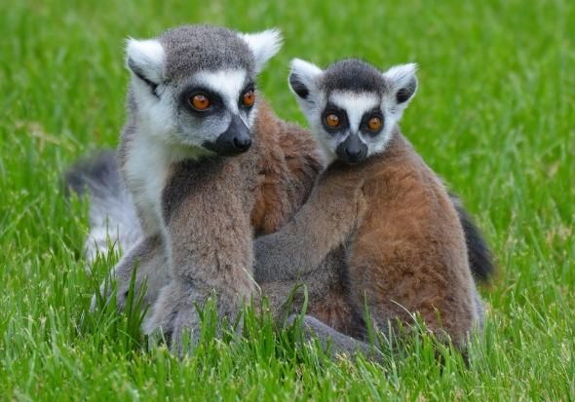 | 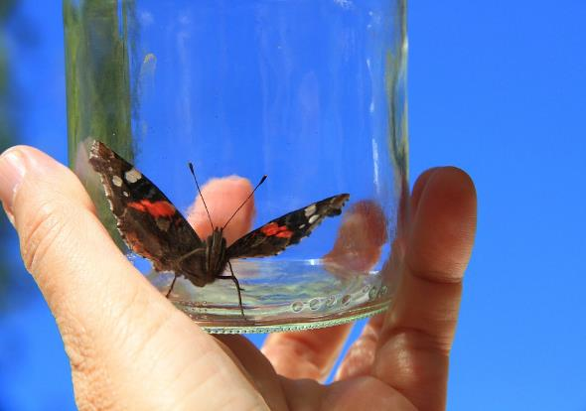
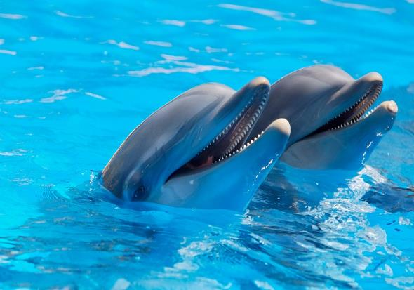 | 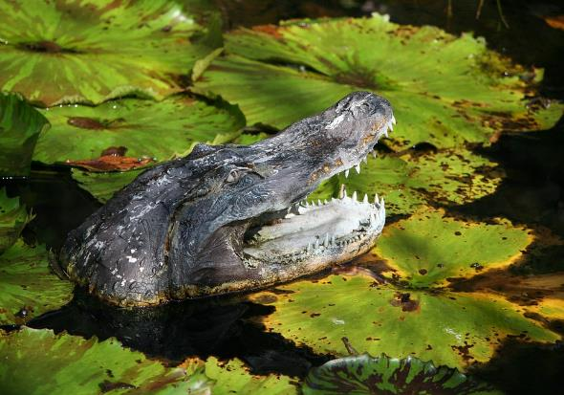
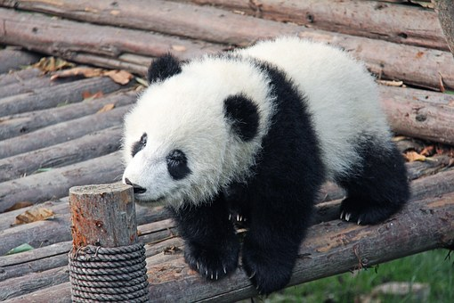 | 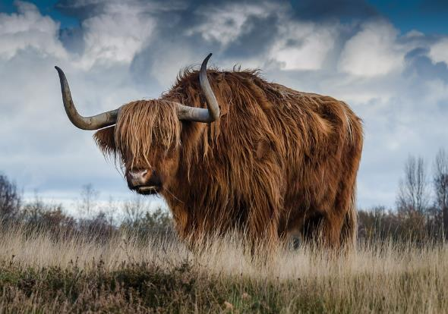
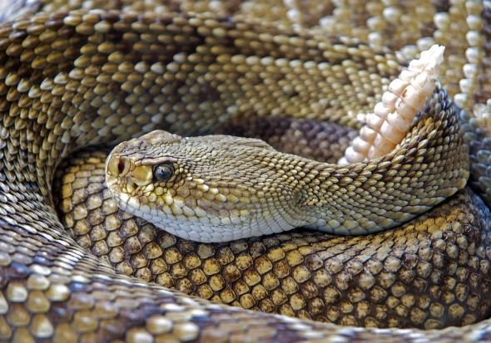 | 